YEAR 11 GENERAL HUMAN BIOLOGY
Task 15: Contraceptives and STIs Test

Multiple Choice 15 Marks

Short Answer 35 Marks

Total 50 Marks

Part 1: Multiple Choice (15 marks)
- Which is the most common STI caused by bacteria?

- Gonorrhea
- Syphilis
- Chlamydia
- Genital warts

- Which of these can NOT be treated with antibiotics?

- Gonorrhoea
- HPV
- Chlamydia
- Trichomoniasis

- Genital herpes are caused by the herpes simplex viruses:

- HIV, HSV-1 and HSV-2.
- HSV-1 and HSV-2.
- HTLV1.
- HPV, HSV-1 and HSV-2.

- Women are at greater risk for HPV genital infections because:

- They have a larger mucosal surface area exposed in the genital area.
- They are often the passive partner in the sex act.
- Of their hormonal makeup.
- Of the frequency of their menstrual cycle.

- Which of the following is a mode of transmission of HIV?

- Urine.
- Tears.
- Breast milk.
- Saliva.

- How can gonorrhea be treated?

- a prescription shampoo
- there is no cure
- freezing or burning
- with antibiotics

- Which of the following is NOT a viral STI?

- herpes
- HIV/AIDS
- scabies
- hepatitis

- How can viral herpes be treated?

- there is no cure
- freezing or burning
- a prescription shampoo
- with antibiotics

- Genital warts are caused by

- the human papilloma virus.
- the herpes complex virus.
- the human immunodeficiency virus.
- Trichomonas vaginalis.

- How often should women have a pap smear (now “cervical screening test”)?

- Every 2 years from age 18 for the rest of their lives
- Every 2 years if they are sexually active until 5 years after they stop being sexually active
- Every 5 years from age 25 for the rest of their lives
- Every 5 years if they are sexually active until 5 years after they stop being sexually active

- An STD for which there is an approved, effective vaccine is:

- herpes
- Hepatitis B
- HIV
- chlamydia

- Which of the following would be the least risky sexual behaviour for transmitting STIs?

- Sex without condoms between two monogamous partners that have been tested
- Sex with a condom with random partners
- Sex with a condom with one regular partner who is also sleeping with other people
- Sex without a condom with multiple partners

- Which of the following ways can you test for HIV?

- Urine sample
- Pap smear
- Genital swab
- Blood test

Part 2: Short Answer (35 marks)

- Complete the following table: (6 marks)
STI | Type | Treatment
Syphilis
Hepatitis A
Pubic lice

- Label the following as true or false and explain your choice. (6 marks)
a) Once you have been infected with chlamydia once you can still get it again but you are less likely to because you have built up resistance.
___________________________________________________________________
___________________________________________________________________
___________________________________________________________________
___________________________________________________________________
b) Practicing abstinence will make it impossible for you to contract Hepatitis C.
___________________________________________________________________
___________________________________________________________________
___________________________________________________________________
___________________________________________________________________
c) You can’t die from HIV but you can die from AIDS because it is a more advanced and serious form of the infection.
___________________________________________________________________
___________________________________________________________________
___________________________________________________________________
___________________________________________________________________

- Explain one way to prevent HIV transmission through each of the following: sexual contact, mother-to-baby and from other bodily fluids. (3 marks)

Transmission | Prevention
Sexual contact
mother-to-baby
other bodily fluids

- Explain 5 ways we can stop or slow the spread of STIs. (5 marks)
1__________________________________________________________________
___________________________________________________________________
___________________________________________________________________
2__________________________________________________________________
___________________________________________________________________
___________________________________________________________________
3__________________________________________________________________
___________________________________________________________________
___________________________________________________________________
4__________________________________________________________________
___________________________________________________________________
___________________________________________________________________
5__________________________________________________________________
___________________________________________________________________
___________________________________________________________________
- Complete the following venn diagram with at least 5 facts about the different forms of hepatitis. You may wish to include facts about transmission, vaccines and symptoms. (5 marks)

Hep B
Hep A
Hep C
6. Referring to the following diagram to answer the questions below.

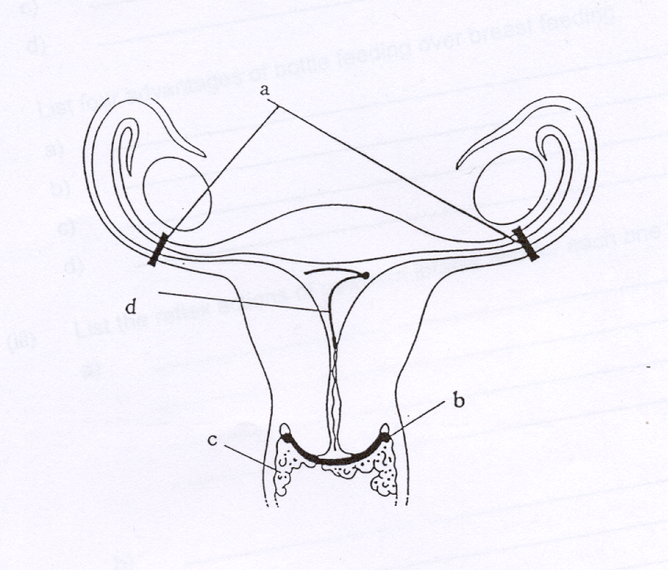
Name each method of contraception indicated by the letters and explain how they work. (4 marks)
A__________________________________________________________________
___________________________________________________________________
___________________________________________________________________
___________________________________________________________________

D__________________________________________________________________
___________________________________________________________________
___________________________________________________________________
___________________________________________________________________

- Give three reasons why a female might choose to use condoms instead of the contraceptive pill. (3 marks)
1__________________________________________________________________
___________________________________________________________________
___________________________________________________________________

2__________________________________________________________________
___________________________________________________________________
___________________________________________________________________

3__________________________________________________________________
___________________________________________________________________
___________________________________________________________________

- Describe three ways in which a hormonal contraceptive prevents pregnancy in the female. (3 marks)
1__________________________________________________________________
___________________________________________________________________
___________________________________________________________________

2__________________________________________________________________
___________________________________________________________________
___________________________________________________________________

3__________________________________________________________________
___________________________________________________________________
___________________________________________________________________

GEHBY Task 15: Contraceptives and STIs Test

NAME:_____________________________
SCORES:
MC: /15

SA: /35

Total: /50

TOTAL: /40

_______ %

TEACHER:__________________________

DATE:______________________________

Section A: Multiple choice (15 Marks)
Answer all questions by circling the most correct answer on the multiple choice answer sheet.

1. a b c d 14. a b c d
2. a b c d 15. a b c d
3. a b c d
4. a b c d
5. a b c d
6. a b c d
7. a b c d
8. a b c d
9. a b c d
10. a b c d
11. a b c d
12. a b c d
13. a b c d

